IAM Task

1. Create one IAM user and assign EC2 and S3 full access roles
Go to IAM dashboard and select on IAM user and select create
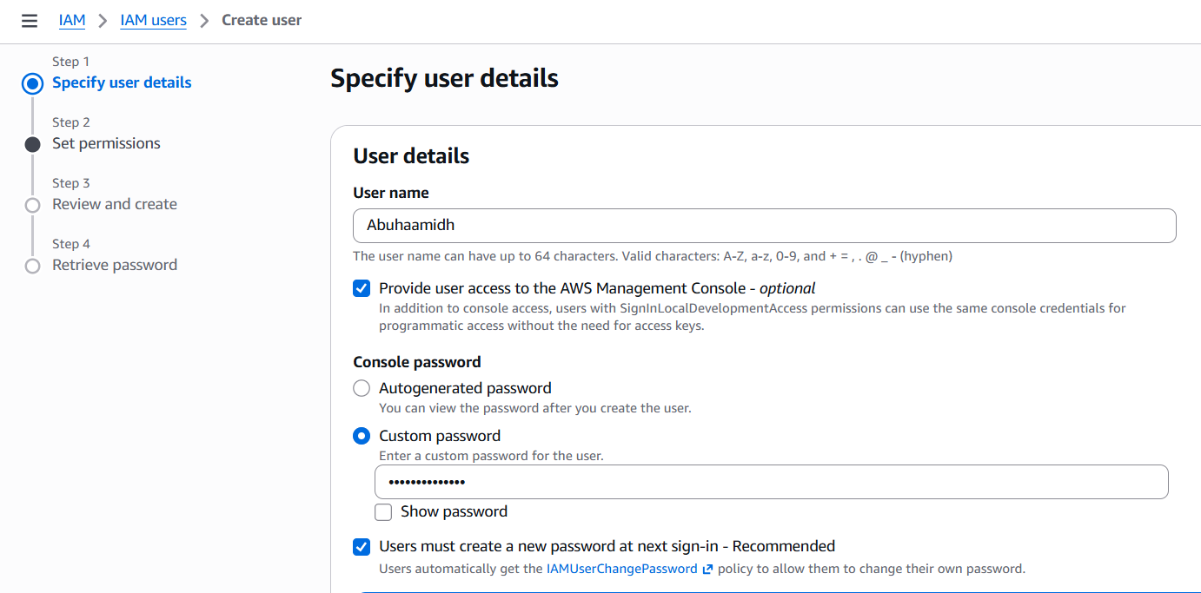
Then give the details as shown
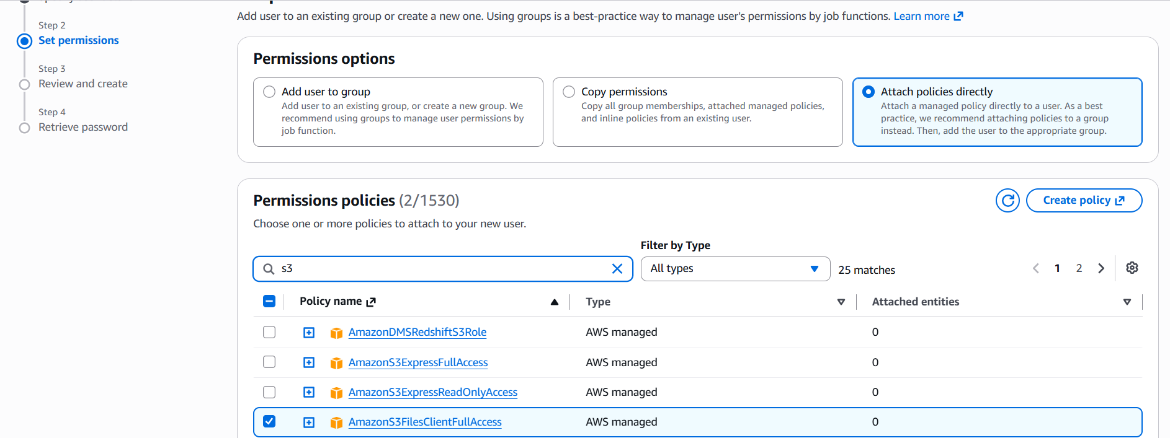
Check it once and review to proceed it further

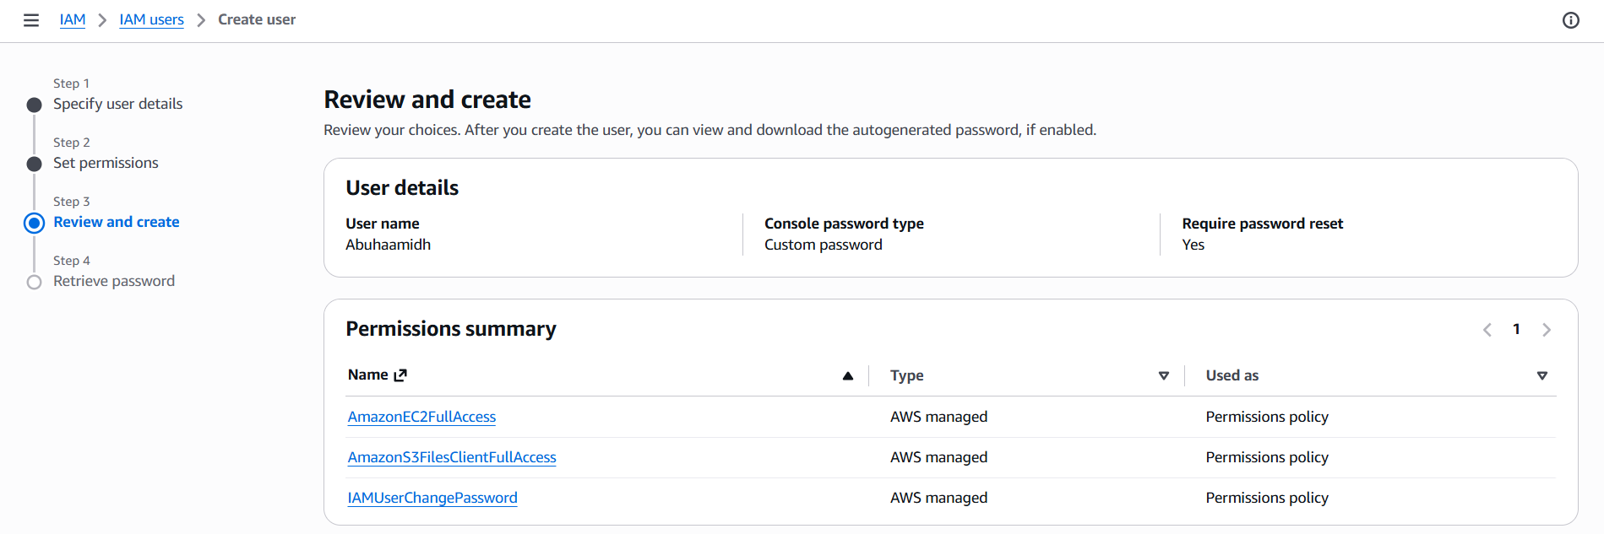
The user has been created and given the S3fullaccess and EC2 full access
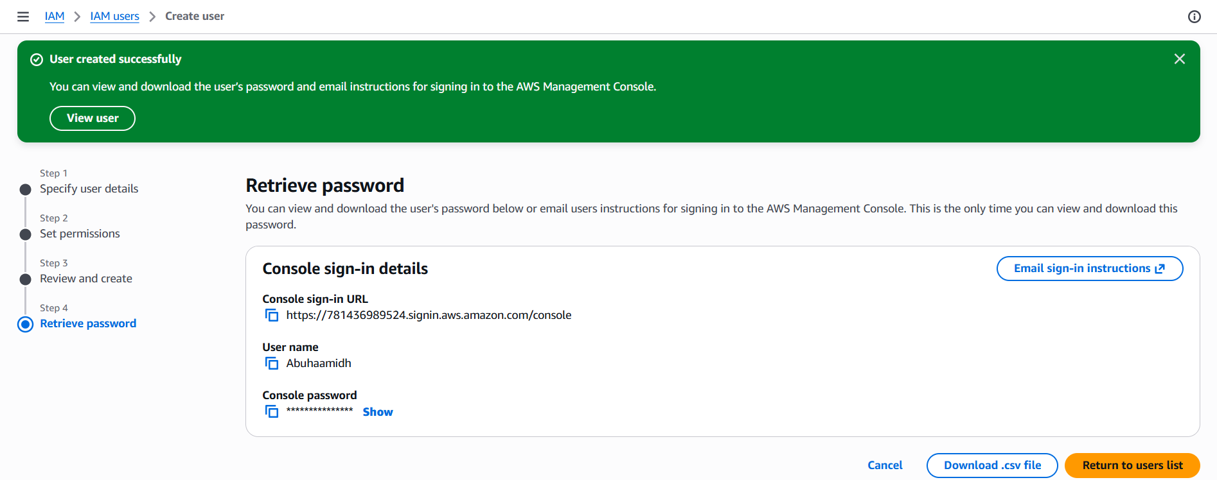

2. Create one group in IAM and assign read access for EC2
Click on user groups create an user group give the name and add the user . attach permissions for only ec2readonlyaccess and create
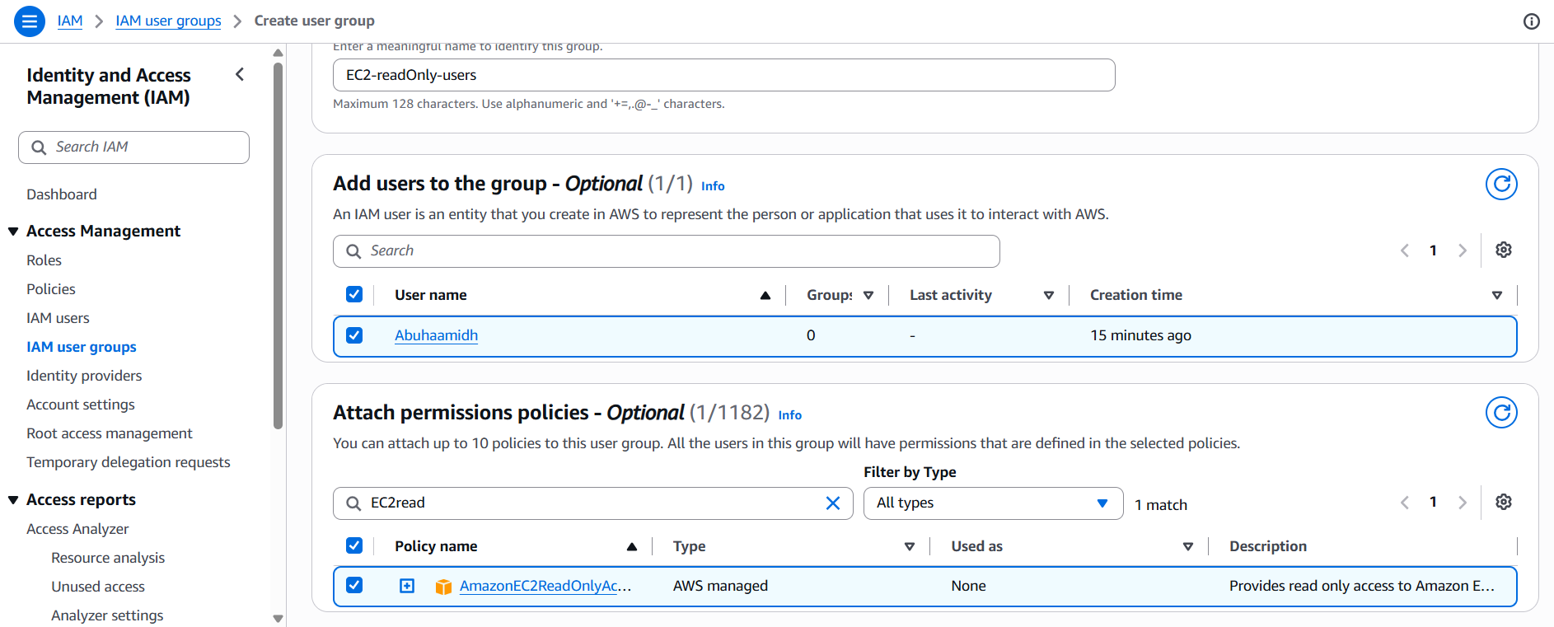
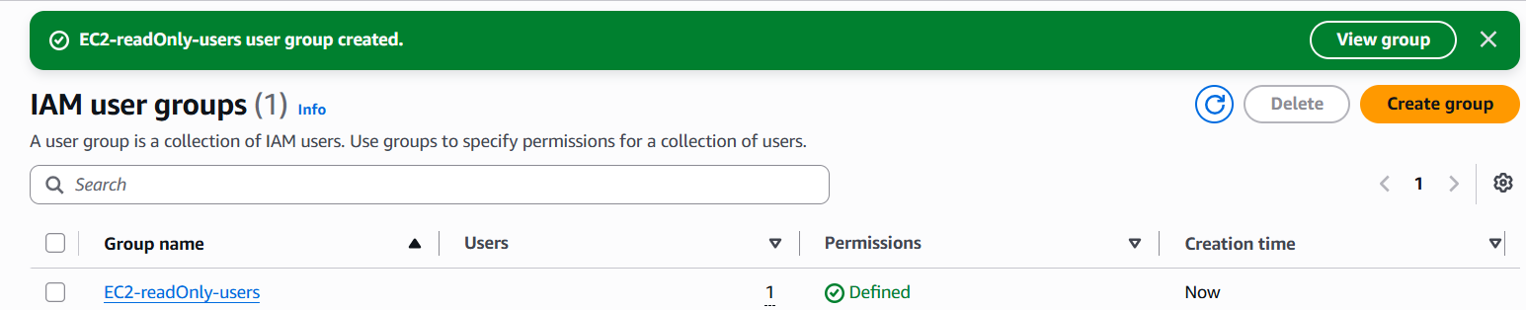

3. Create a new user named "Devops" and add to the group created in task 2
Create a user and name Devops
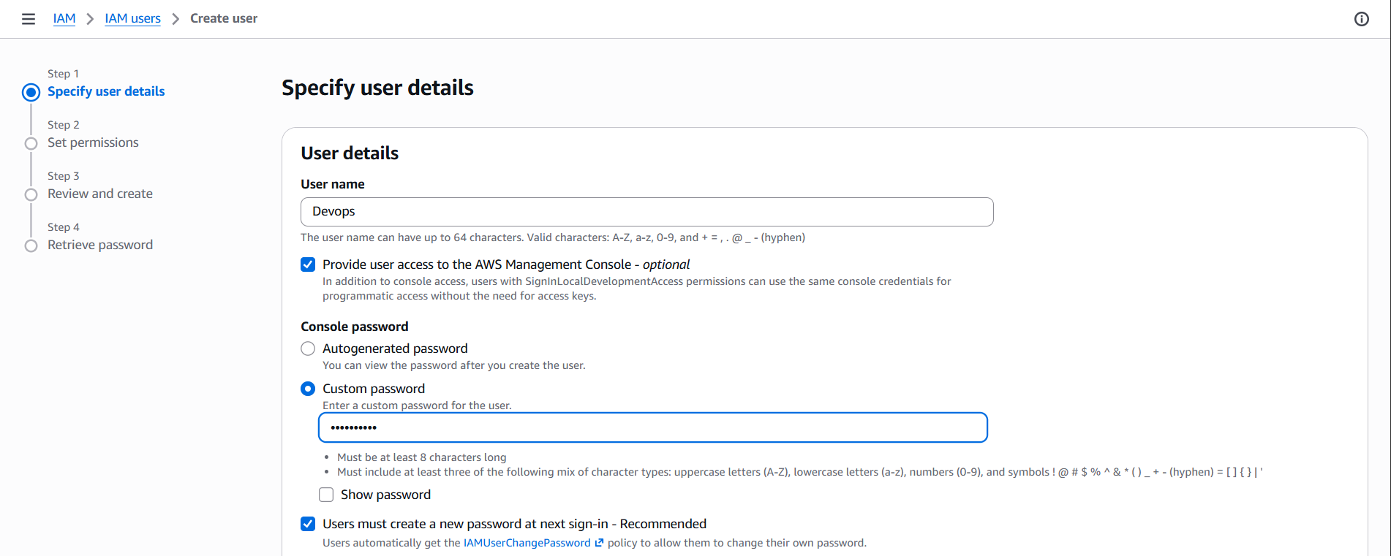
And click on add user to the group and check the user
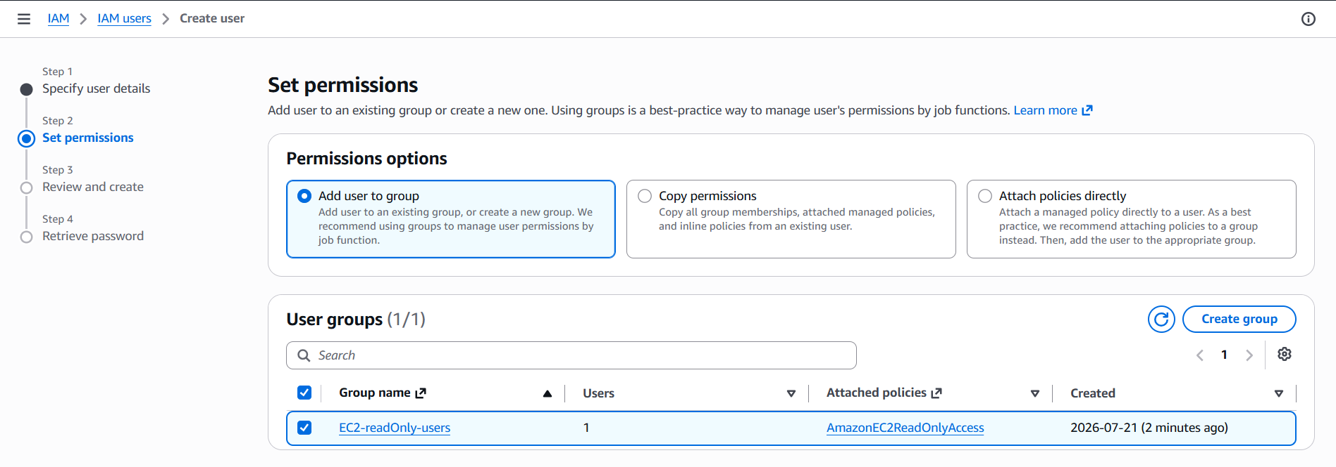
Here you can see there are two users in the user list
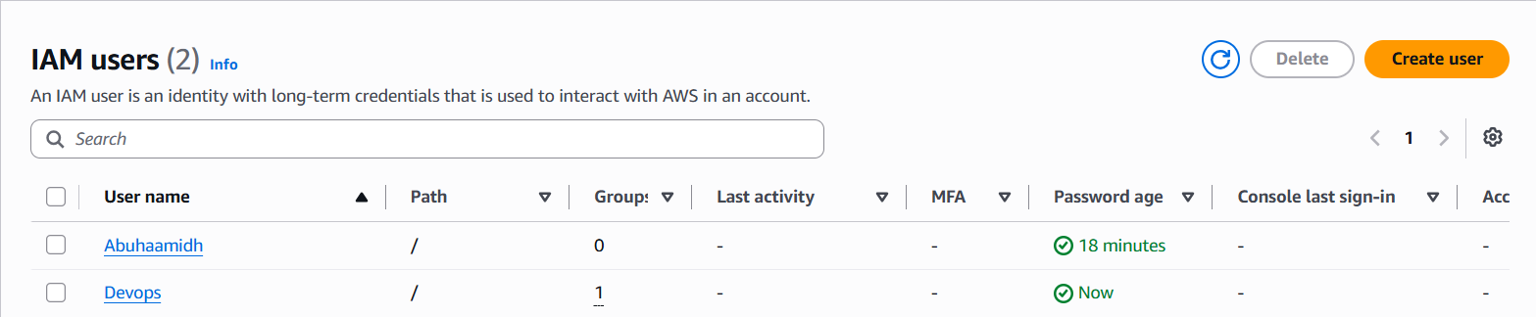

4. Write a bash script to create an IAM user with VPC full access
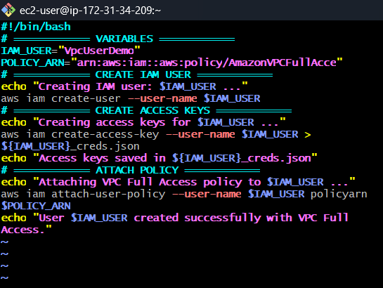
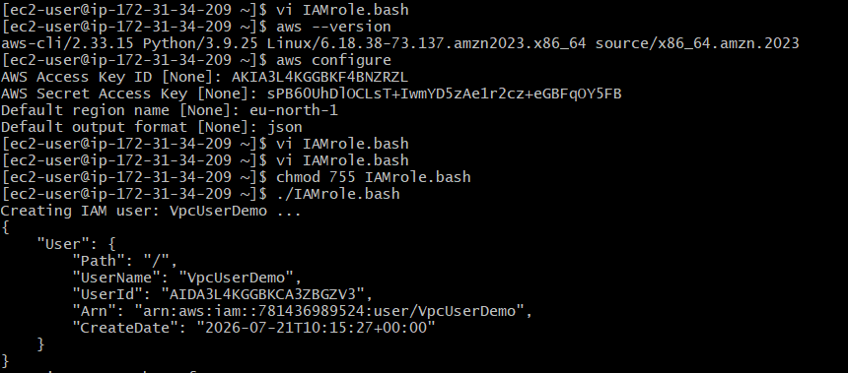

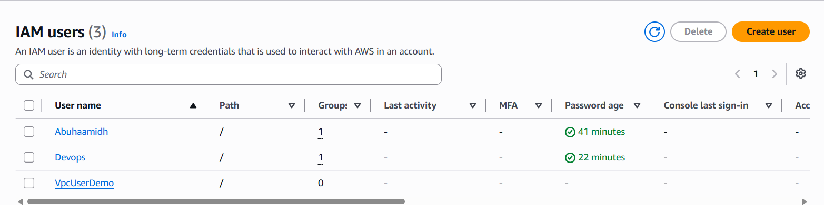

5. Create an IAM policy to allow EC2 access for a specific user in specific regions only
I created an IAM user name, EC2-Region-Restrict-Policy and give amazon ec2fullacess for specific user for specific region
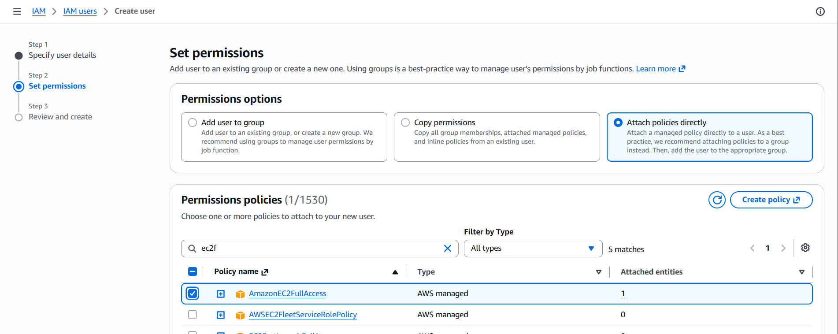
Go to users and select the user what you need to add the specific policy that you are created.
Go to IAM → Users, click the target user, Permissions → Add permissions → Attach existing policies
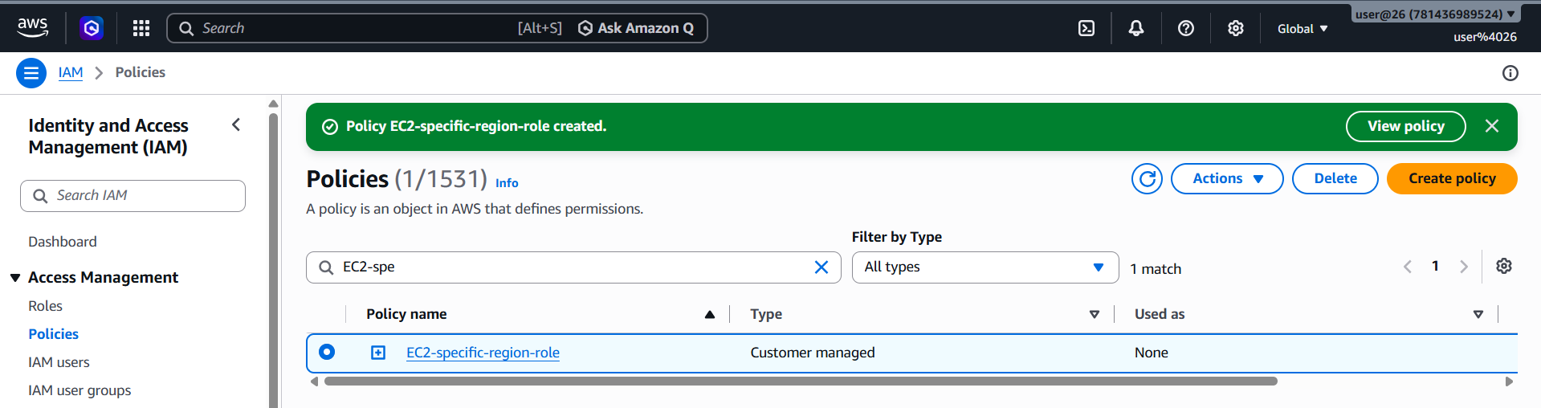
So the policy has been attached
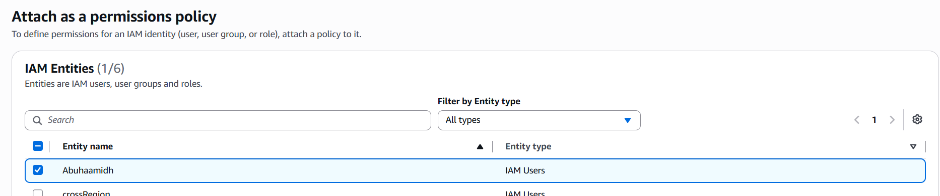

6. We have two accounts: Account A and Account B. Account A user should access an S3 bucket in Account B
Create an IAM User, IAM → Users → Create user.
Attach AmazonS3ReadOnlyAccess.
Click Next → Create user
Create Access keys
Open the Security credentials tab and Click Create access key.
aws configure
Enter:
AWS Access Key ID, AWS Secret Access Key, Default region, Default output format
Now Add Bucket Policy
Test from Account A
List the bucket contents using aws s3 ls s3://<Bucket name>
Expected output:
2026-07-21 10:30:00 20 test.txt
Verify it using ls
View the file using cat test.txt
